**Practical no.5**

#include <90s8535.h>

#include <delay.h>

// Declare your global variables here

unsigned int tc=0;

interrupt[TIM0_OVF]void timer0_ovf_isr(void)

{

TCNT0=6;

if(++tc==1000)

{

PORTA=PORTA^0x01;

tc=0;

}

}

void main(void)

{

PORTA=0x00;

DDRA=0x00;

TCCR0=0x02;

TCNT0=0x00;

TIMSK=0x01;

#asm("sei");

while (1)

{

// Place your code here

};

}

**Circuit:-**

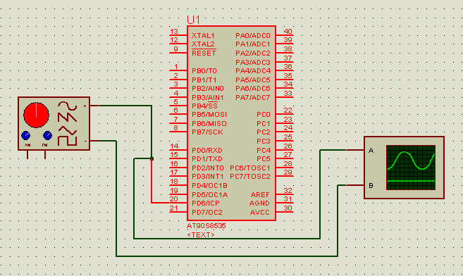

**OUTPUT:-**

